**BlinkIT Analysis-**

Performed data cleaning and used SQL to analyze sales by outlet size, location type, and item fat content. Key insights included total and percentage sales by category, helping identify trends and support business decisions.

* See all the data imported-

**select * from blinkit_data;**

**Data Cleaning-**

**• Disabled Safe Update Mode:  
Executed SET SQL_SAFE_UPDATES = 0; to allow updates without a WHERE clause.**

**• Standardized Categorical Values:  
Updated inconsistent entries in the Item_Fat_Content column:**

**Converted 'LF' and 'low fat' to 'Low Fat'**

**Converted 'reg' to 'Regular'**

**Retained other values as-is**

**• Re-enabled Safe Update Mode:  
Executed SET SQL_SAFE_UPDATES = 1; to restore update restrictions for safety.**

**SET SQL_SAFE_UPDATES = 0;**

**UPDATE blinkit_data**

**SET Item_Fat_Content =**

**CASE**

**WHEN Item_Fat_Content IN ('LF', 'low fat') THEN 'Low Fat'**

**WHEN Item_Fat_Content = 'reg' THEN 'Regular'**

**ELSE Item_Fat_Content**

**END;**

**SET SQL_SAFE_UPDATES = 1;**

After executing this query check the data has been cleaned or not using below query.

**Select distinct(Item_Fat_Content) from blinkit_data**

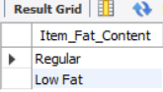

KPI’s Requirements-

## TOTAL SALES:

**SELECT**

**CAST(SUM(Sales) / 1000000 AS DECIMAL (10 , 2 )) AS Total_Sales_Millions**

**FROM**

**blinkit_data;**

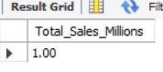

## AVERAGE SALES:

**SELECT**

**CAST(AVG(Sales) AS DECIMAL (10 , 2 )) AS Avg_Sales**

**FROM**

**blinkit_data;**

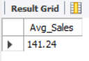

## NO. OF ITEMS:

**SELECT**

**COUNT(*) AS No_Of_Items**

**FROM**

**blinkit_data;**

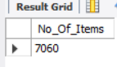

## AVERAGE RATING

**SELECT**

**AVG(Rating) AS Average_Rating**

**FROM**

**blinkit_data;**

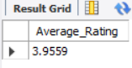

Granular Requirements-

## TOTAL SALES , AVG SALES, NO. OF ITEMS, AVG RATING FOR FAT CONTENT:-

**SELECT**

**Item_Fat_Content,**

**CAST(SUM(Sales) AS DECIMAL (10 , 1 )) AS Total_Sales,**

**CAST(AVG(Sales) AS DECIMAL (10 , 1 )) AS Avg_Sales,**

**COUNT(*) AS No_Of_Items,**

**CAST(AVG(Rating) AS DECIMAL (10 , 2 )) AS Avg_Rating**

**FROM**

**blinkit_data**

**GROUP BY Item_Fat_Content**

**ORDER BY Total_Sales DESC;**

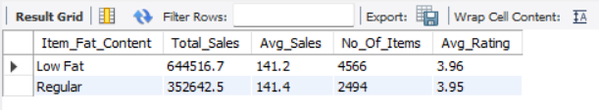

## TOTAL SALES, AVG SALES, NO. OF ITEMS, AVG RATING FOR ITEM TYPE:

**SELECT**

**`Item Type`,**

**CAST(SUM(Sales) / 1000 AS DECIMAL (10 , 1 )) AS Total_Sales_Thousands,**

**CAST(AVG(Sales) AS DECIMAL (10 , 1 )) AS Avg_Sales,**

**COUNT(*) AS No_Of_Items,**

**CAST(AVG(Rating) AS DECIMAL (10 , 2 )) AS Avg_Rating**

**FROM**

**blinkit_data**

**GROUP BY `Item Type`**

**ORDER BY Total_Sales_Thousands DESC;**

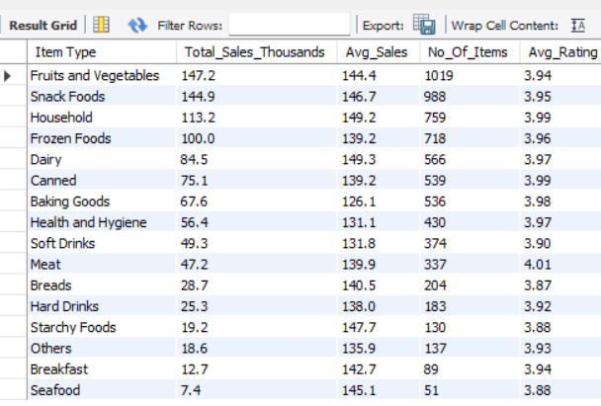

## FAT CONTENT BY OUTLET FOR TOTAL SALES:

**SELECT**

**`Outlet Location Type`,**

**SUM(CASE WHEN Item_Fat_Content = 'Low Fat' THEN Sales ELSE 0 END) AS Low_Fat,**

**SUM(CASE WHEN Item_Fat_Content = 'Regular' THEN Sales ELSE 0 END) AS Regular**

**FROM blinkit_data**

**GROUP BY `Outlet Location Type`**

**ORDER BY `Outlet Location Type`;**

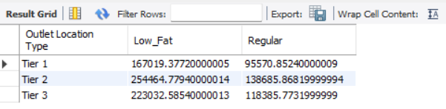

## TOTAL SALES, AVG SALES, NO. OF ITEMS , AVG RATING FOR OUTLET ESTABLISHMENT YEAR:-

**SELECT**

**`Outlet Establishment Year`,**

**CAST(SUM(Sales) / 1000 AS DECIMAL (10 , 1 )) AS Total_Sales_Thousands,**

**CAST(AVG(Sales) AS DECIMAL (10 , 1 )) AS Avg_Sales,**

**COUNT(*) AS No_Of_Items,**

**CAST(AVG(Rating) AS DECIMAL (10 , 2 )) AS Avg_Rating**

**FROM**

**blinkit_data**

**GROUP BY `Outlet Establishment Year`**

**ORDER BY `Outlet Establishment Year` ASC**

**;**

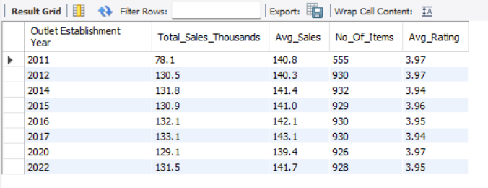

Charts Requirements-

## PERCENTAGE OF SALES BY OUTLET SIZE:

**SELECT**

**`Outlet Size`,**

**SUM(Sales) AS Total_Sales,**

**ROUND(100 * SUM(Sales) / (SELECT SUM(Sales) FROM blinkit_data), 2) AS Sales_Percentage**

**FROM blinkit_data**

**GROUP BY `Outlet Size`**

**ORDER BY Total-Sales DESC;**

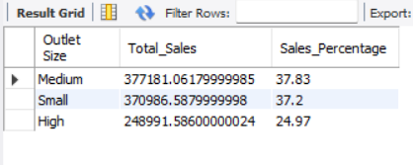

## TOTAL SALES, AVG_SALES, NO. OF ITEMS, AVG_RATING FOR OUTLET LOCATION:

**SELECT**

**`Outlet Location Type`,**

**cast(SUM(Sales) as decimal(10,2)) AS Total_Sales,**

**cast(AVG(Sales) as decimal(10,2)) AS Avg_Sales,**

**COUNT(*) AS No_Of_Items,**

**AVG(Rating) AS Avg_Rating**

**FROM**

**blinkit_data**

**GROUP BY `Outlet Location Type`**

**ORDER BY Total_Sales DESC;**

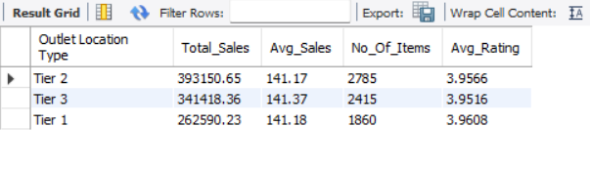

## ALL METRICES BY OUTLET TYPE-

**SELECT `Outlet Type`,**

**cast(SUM(Sales) as decimal(10,2)) as Total_Sales,**

**ROUND(100 * SUM(Sales) / (SELECT SUM(Sales) FROM blinkit_data), 2) AS Sales_Percentage,**

**cast(avg(Sales) as decimal(10,2)) as Avg_Sales,**

**count(*) as No_Of_Items,**

**avg(Rating) as Avg_Rating**

**from blinkit_data**

**group by `Outlet Type`**

**order by Total_Sales desc;**

